Shahjalal University of Science and Technology

Department of Computer Science and Engineering



Title of the Project

Package and FnF Suggestion Generator

**Student:***(Md Shah Ali, 2013337023, 4/2, Dept. of FET)*

**Supervisor:***(Professor Dr. Mohammad Reza Selim, Professor, Dept. of CSE)*

3rd September 2018

Shahjalal University of Science and Technology

Department of Computer Science and Engineering



Title of the Project

Package and FnF Suggestion Generator

A Project submitted to the Department of Computer Science and Engineering,  
Shahjalal University of Science and Technology, in partial fulfillment of the requirements  
for the degree of B.Sc (2nd Major) in Computer Science and Engineering.

**Student:***(Md Shah Ali, 2013337023, 4/2, Dept. of FET)*

**Supervisor:***(Professor Dr. Mohammad Reza Selim, Professor, Dept. of CSE*

2nd September 2018

Recommendation Letter from Supervisor

This student, Md Shah Ali, whose project entitled“Package and FnF Suggestion Generator”, is under my supervision and agree to submit for examination.

Professor Dr. Reza Selim

Professor  
Dept. of CSE

# Qualification Form of B.Sc. (2nd Major) Degree

We hereby certify that this project titled “Package and FnF Suggestion Generator”, submitted by Md Shah Ali, conforms to acceptable standards and is fully adequate in scope and quality to fulfill the requirements for the degree of B.Sc. (2nd Major) in Computer Science and Engineering.

|  |  |  |
| --- | --- | --- |
| ________________  Head of the Dept.  Professor Dr. Reza Selim  Professor | _______________________  Chairman, Exam. Committee  Professor Dr. Reza Selim  Professor | __________________  Supervisor  Professor Dr. Reza Selim  Professor |

# Abstract

The application “Package and FnF Suggestion Generator” is developed with an intention to help the people of Bangladesh choosing their best package, corresponding FnF and Super FnF and best operator for them based on their call log. One can easily activate his/her suggested best package and add suggested FnF and Super FnF with this app.

The application will detect the current package automatically by sending SMS or through USSD call, insert outgoing call log into database, read outgoing call log and compare current package cost with the other package cost for current call log and give you suggestion. For new outgoing call after installation, it will automatically insert this call details into database.

1. Chapter 1 2

Introduction 2

1.1 Beginning 2

1. Chapter 2 2

Testing 2

2.1 Good 2



Introduction

Pineapple is a delicious tropical fruit with a fine flavor and high nutritive value.This fruit is highly perishable and seasonal. Mature fruit contains 14% of sugar; a protein digesting enzyme, bromelin and good amount of citric acid, melic acid and vitamin A and B. It is harvested mostly in June, July and August. It is one of the most important commercial fruit crops in the world. According to ***hridoy and sazzad*** Thailand is the largest producer of pineapple, accounting for 13% of global output, followed by Brazil and Costa Rica. If the excess fruits in the season are preserved by any means ensuring the quality, these fruits can be exported to other countries as well as meet the off-season demand for pineapple.

Pineapple juice is commonly preserved by thermal treatment for inactivating microorganisms and enzymes which reduces nutritional and flavor quality and produces undesirable off-favor compounds (***6, 11, 21 from Orange.pdf***). Besides different preservatives are also used for the preservation of pineapple juice which cause off-flavor and health problem (***refrence)***. The challenge of preserving the sensorial and nutraceutical properties as well as extending the microbiological shelf-life suggests the need of non-thermal technologies for preservation of fresh pineapple juice. PEF processing is the novel technique of preservation that involves a very short discharge period (microseconds) and minimizes the heating of foods and has the potential to preserve the fresh like qualities of foods (***Pomegranate.pdf)***.

Pulsed electric fields PEF is a non-thermal method of food preservation that uses short pulses of electricity for microbial inactivation and causes minimal detrimental effect on food quality attributes. PEF technology aims to offer consumers high-quality foods. For food quality attributes, PEF technology is considered superior to traditional thermal processing methods because it avoids or greatly reduces detrimental changes in the sensory and physical properties of foods. PEF technology aims to offer consumers high-quality foods. For food quality attributes, PEF technology is considered superior to traditional thermal processing methods because it avoids or greatly reduces detrimental changes in the sensory and physical properties of foods (***Quass, 1997from PEF.pdf***).

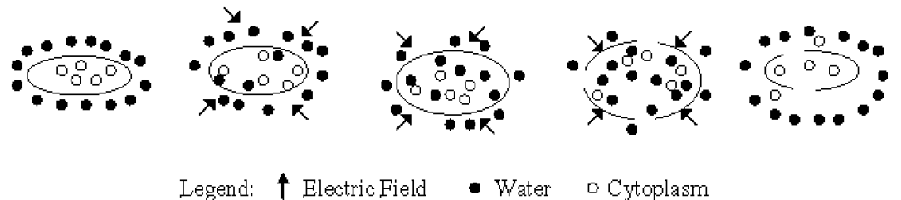

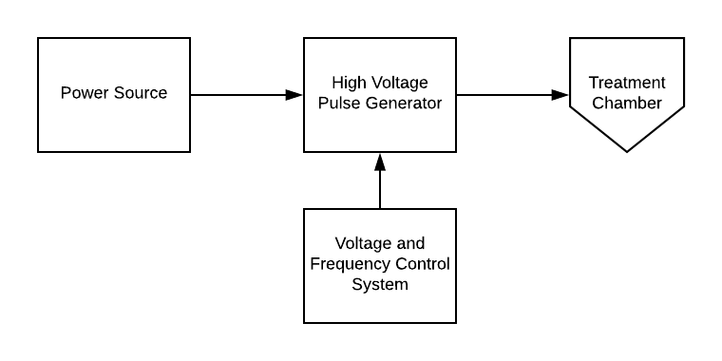

Pulse electric field phenomenon:

. when an electric field is applied in a biological membrane, the conductivity and permeability of the membrane rapidly increases, the process is known as electroporation. Electroporation technology enhances the transesterification process, producing pores in the microbial cells by exposing the substrate to electrical fields.

Thus applying high electric field on a transmembrane its potential increases because of the additional free charges that accumulate at both membrane surfaces. These charges are opposite and attract each other, resulting in membrane compression. On the other hand, viscoelastic forces oppose the electro-compression of the membrane. However when the transmembrane potential reaches approximately 1V, the electrocompressive forces exceed the viscoelastic properties of the membrane and membrane breakdown occur. The number and size of the pores depend on the electric field strength and treatment time. The electric field intensity at which the pore occurs is called the threshold or critical electric field.  
The applied electric field must be higher than the critical electric field for the formation of pore.

There are four typical range of electroporation can be occurred depending on the applied factor and each range has typical pore properties. Before attaining a certain electric field there will no detectable electroporation means no pore will formed even if formed, are too small and short-lived for measurable transport. The next range is reversible electroporation where a temporary pathway is provided by the pore which after the electric pulse will gradually reseal. After applying larger electric field or more exposure time the irreversible electroporation range is occurred. Here most pores either do not reseal, or reseal too slowly to preserve cell viability. Cells thus gradually disintegrate and release their con-tents. Irreversible electroporation are two types, first is Thermally not damaged and the second is thermally damaged. For thermally damaged electroporation it needs largest electric field or longest exposure time. The electric current causes the sufficient temperature rises to damage the cell contents(protein denaturation above 50 0C, DNA melting above 70 0C).

There are four typical range of electroporation can be occurred depending on the applied factor and each range has typical pore properties. Before attaining a certain electric field there will no detectable electroporation means no pore will formed even if formed, are too small and short-lived for measurable transport. The next range is reversible electroporation where a temporary pathway is provided by the pore which after the electric pulse will gradually reseal. After applying larger electric field or more exposure time the irreversible electroporation range is occurred. Here most pores either do not reseal, or reseal too slowly to preserve cell viability. Cells thus gradually disintegrate and release their con-tents. Irreversible electroporation are two types, first is Thermally not damaged and the second is thermally damaged. For thermally damaged electroporation it needs largest electric field or longest exposure time. The electric current causes the sufficient temperature rises to damage the cell contents(protein denaturation above 50 0C, DNA melting above 70 0C). ­­­­­­

The range boundaries depend on the cell type and are affected by the properties of the medium in which the cells are exposed – its electrical conductivity, osmolarity, and the solutes it contains. As the exposure duration (i.e., electric pulse length) increases, the transitions between adjacent regions occur at lower fields. From the figure-2 it can be seen that The range of detectable poration, however, has an asymptotic lower bound – below a certain field strength, no transmembrane transport is detected no matter how long the applied pulses.

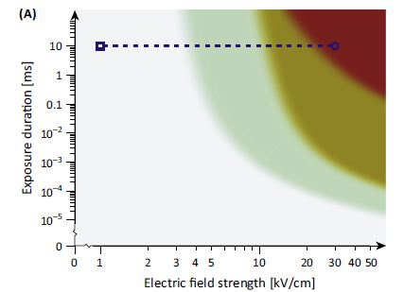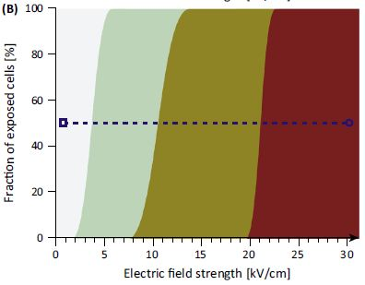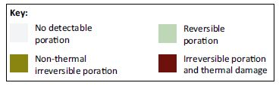

Fig-2: Effects of electric field strength and exposure time on range of electroporation.



Materials and Methods

**Materials**

The fruit sample viz. pineapple (*Ananascomosas* L.).

**Juice preparation**

Fresh pineapples from a local super shop named Agora were used for this process. Then the pineappleswere debarked, cut into small pieces and blended with juice blender (**Panasonic)**. The obtained juice was then filtered by a filter cloth and clear juice was collected in a sterilized bottle. Until the treatment, the juicewasstored at -20 ºC and before the treatment they were thawed at ambient temperature.

**PEF treatment**

Pineapple juice samples were processed through a pilot plant scale PEF system with electric field strengths of 5, 10, 13 kV/cm and a mean total treatment time of 1 ms. and aseptically packed into 213 g (6 oz) plastic cup containers and stored at 4 ºC for 30 days.

**Phytochemical Content and Antioxidant Activities of the Fresh Juice**

**Sample Extraction**

The sample was centrifuged at 3,000 rpm(Hettich-Zentrifugen, Tuttlingen, Germany) for 15 min.The supernatantwas then stored at −20C until further analyses.

**Determination of Total Phenolic Content**

Total phenoliccontent in the sample extract was assessed using theFolin–Ciocalteau assay (SLINKARD) withslight modification. For the analysis, 20 μL each of extract,gallic acid standard or blank were taken in separate testtubes and to each 1.58 mL of distilled water was added, followedby 100 μL of Folin–Ciocalteau reagent, mixed welland within 8 min, 300 μL of sodium carbonate was added.The samples were vortexed immediately and the tubes wereincubated in the dark for 30 min at 40C. The absorbancewas then measured at 765 nm in a UV-Vis spectrophotometer(Aquarius 7400, Cecil, Cambridge, England). Theresults were expressed in mg gallic acid equivalent (GAE)/100 g.

**Determination of Total Flavonoid Content**

The flavonoidcontent was determined by aluminum trichloridemethod (Chang et al. 2002). Briefly, 0.5 mL of the extractwas mixed with 1.5 mL of 95% ethanol, 0.1 mL of 10% aluminumtrichloride (AlCl3), 0.1 mL of 1 M potassiumacetate, and 2.8 mL of deionized water. After incubation atroom temperature for 40 min, the reaction mixture absorbancewas measured at 415 nm against deionized waterblank in a UV-Vis spectrophotometer (Aquarius 7400,Cecil). Results were expressed as quercetin equivalent(mgQE/100 g) of sample.

**Determination of DPPH Activity**

Radical scavenging activity of the sample extracts was measured by determining the inhibition rate of DPPH (2, 2-diphenyl-1- picrylhydrazyl) radical (Brand-Williams et al. 1995). Precisely, 100 μL of extracts were added to 1.4 mL DPPH radical methanolic solution (10−4 M). The absorbance at 517 nm was measured at 30 min against blank (100 μL methanol in 1.4 mL of DPPH radical solution) using a UV-Vis Spectrophotometer (Aquarius 7400, Cecil). The results were expressed in terms of radical scavenging activity using the following equation

Radical scavenging activity (%) $=\frac{Ao-As}{Ao} ×100$

Where,Ao is absorbance of control blan, and As is absorbance of sample extract.

This is for testing git hub only

This is for testing git hub only

This is for testing git hub only